Computer Safety Do’s and Don’ts
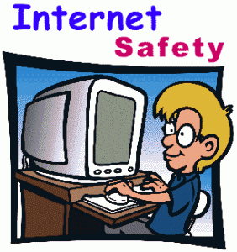
The internet can be a fun place to learn! We can find information for projects, music from our favorite band, episodes of our favorite shows, pictures of our favorite animals and even information about our family. But we have to be SAFE when we are on the internet too! Most people on the internet are good but there are some bad people and bad things that we want to stay away from.

Internet Do’s
- Do ask for help from a trusted adult before we get online.
- Do stay only on the websites that we have agreed with trusted adults are good websites.
- Do tell a trusted adult if someone makes us feel uncomfortable online
- Do talk to our friends online
- Do look at some of our favorite websites from our list of good websites to visit that we made with our trusted adult

Internet Don’ts
- Don’t tell anyone online where we live or other personal information (phone #, birthday, etc.)
- Don’t meet up with anyone we meet online
- Don’t go to websites that we haven’t agreed to be a good website with a trusted adult
- Don’t send people we don’t know pictures of us online
- Don’t send inappropriate pictures of ourselves to others

