The INTERNET is forever!
Everything you post online can NEVER be erased.
Others can EASILY share what you post online…even if you don’t want them to!
*Remember* DO practice safe internet behaviors.
DO NOT post private information online (PRIVATE means things like your address, phone number, information about money or bank account, social security number, naked pictures, and other things people can use to find you and hurt you).
DO NOT post pictures of yourself without clothes online.
DO NOT expect others to keep your information safe.
DO NOT share others’ information without their permission.

TEXTING: THE DO'S AND DON’TS

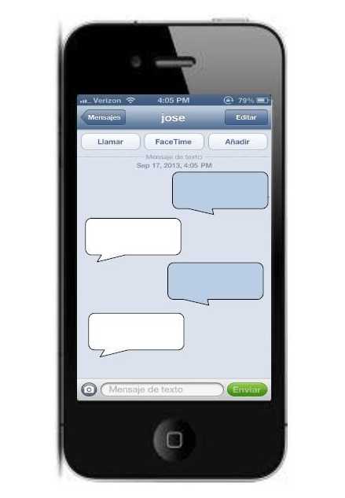
DO DO NOT
1. DO have only friendly conversations
2. DO say only nice things
3. DO text only people you know well
4. DO say only things that are true
5. DO ignore mean things
6. DO text only NON private things
7. DO text only people who want to text you
8. DO ask permission from the sender before showing or sending the text to others

1. DO NOT have mean conversations
2. DO NOT say mean things
3. DO NOT text people you do not know well
4. DO NOT say things that are not true
5. DO NOT text private information or pictures to others
6. DO NOT keep texting someone you do not want to text
7. DO NOT text someone who does not want to text you
8. DO NOT forward any text messages without permission

Internet & Texting Safety Review!
If you think the answer to the following questions is YES circle the YES beside the question. If you think the answer is NO circle the NO beside the question.
- It is okay to post a picture of myself naked online. YES NO
- It is okay for me to post my address online. YES NO
- I can easily delete anything I post on the internet. YES NO
- I can control what other people text or post online. YES NO
- I can post pictures of my friends with their permission. YES NO
- I can send a text to my friend if I have their permission. YES NO
- It is okay to post a picture of myself fully dressed online. YES NO
- It is okay to forward a naked picture of someone else. YES NO
- It is okay to send mean text messages to others. YES NO
- It is okay to text or email people I have never met. YES NO
- I should only say truthful things online. YES NO

